L16: Preparation Assignment Key

Part I: Concepts

- Pick from the list of graphs below, which graphs you can use to describe categorical data:
  - Histograms
  - Pie Charts
  - Boxplots
  - Bar Charts

- When given a sample, what is the formula to compute $\hat{p}$? Explain which each variable stands for in your formula.
$\hat{p}= \frac{x}{n}$ n = total sample size and x = number of individuals in sample the with the characteristic you are focusing on.

- What is the mean of the sampling distribution of the samples proportion $\hat{p}$? (State this answer in words—not just a symbol.)

P or the population proportion

- What is the standard deviation of the sampling distribution of the samples proportion $\hat{p}$? (You may state this answer in symbols. Please include what each symbol in your formula stands for.)

$Standard Deviation of \hat{p}= \sqrt{\frac{p(1-p)}{n}}$ where n = total sample size and p = the true population proportion, which is also the mean of the distribution of $\hat{p}$

- What is the difference between categorical and quantitative data? What are a couple of examples of categorical data (open-ended)?
Answers may vary.
Categorical data groups the individuals in your study into categories, while numerical data assigns numbers to the individuals in your study. These numbers are a subset of the real numbers and can be discrete or continuous.

Part II: Application
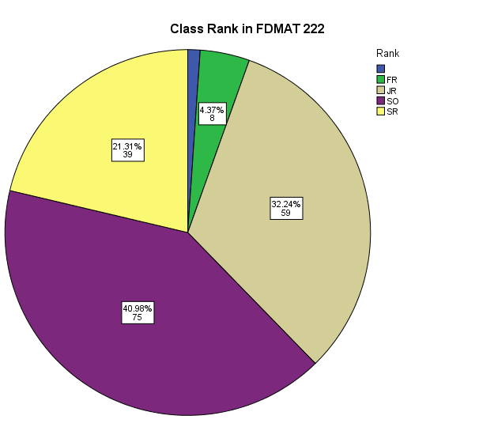
- Open the file: Class Survey.xlsx (Class Survey. Sav). Create a pie chart for Class Rank. Label it. Post it here.

- Next create a bar graph for Class Rank. Label it. Post it here. (222 and 223 students must use SPSS)
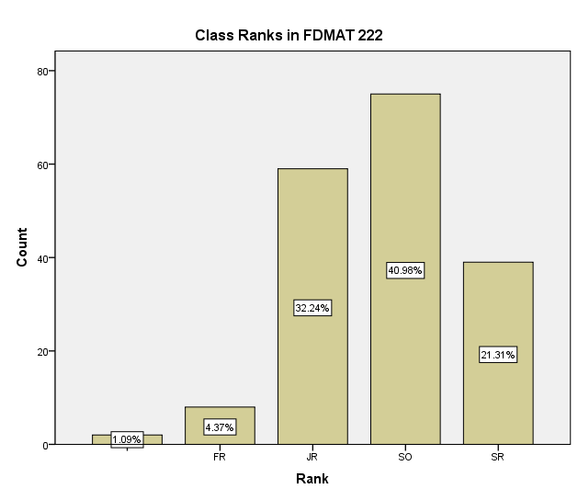
- Use at least five descriptors to describe the data above.
These answers may vary. Students may use proportions to describe the data. They may also describe their sample with words, etc. They may use a frequency table.
Examples of proportions:
- $\hat{p}$ _{Fr} = 0.0437
- $\hat{p}$ _{Soph} = 0.4056
- $\hat{p}$ _{Jr} = 0.3224
- $\hat{p}$ _{Sr} = 0.2131
Frequency Table
Class | Count | Proportion
Freshman | 8 | 0.0437
Sophomore | 75 | 0.4056
Junior | 59 | 0.3224
Senior | 39 | 0.2131
Other | 2 | 0.0109
Total | 183 | 1.0

- Seven Percent is the true unknown percent of the population do not have traditional phones and instead rely on cell phones (7% is p). Suppose a random sample of 750 telephone users is obtained. What is the probability that more than 60 phone users (8%) in the survey use only cell phones?

  - What is the “mean” and standard deviation of the sampling distribution based on 750 telephone users?

The mean is 7% or 0.07 in this sample and the standard deviation is 0.0093

  - What is the z-score you would use?
Z = 1.075

  - What is the probability that more than 8% in the survey use only cell phones?

Area = 0.1412

